Online Training for PIP Members
Substance Misuse
- Prevention Solutions EDC- https://preventionsolutions.edc.org/services/online-courses
- CDC – https://www.cdc.gov/learning/index.html then scroll down and click ‘Find more Courses.’ Redirects to train.org, create an account. Search ‘alcohol’ - Alcohol Screening and Brief Intervention Training
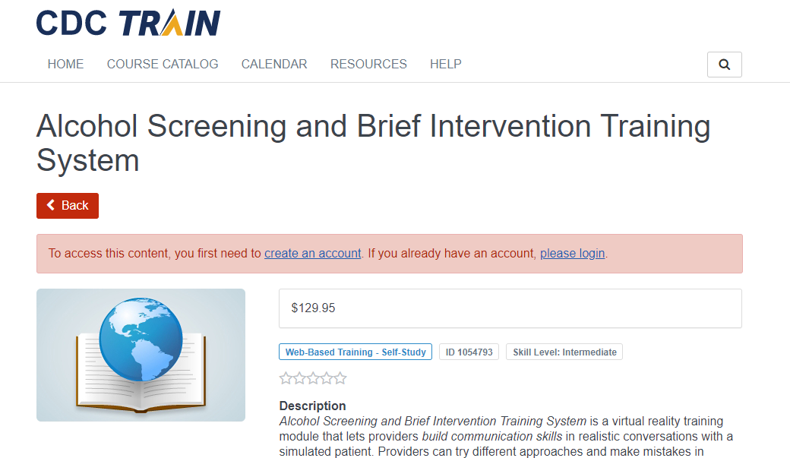
- Health E Knowledge (free courses, but good to share!) - https://healtheknowledge.org/course/index.php
- Institute for Research, Education, and Training, on Addictions - https://ireta.org/training/online-courses/ (free but CEUs have a cost)

Suicide Prevention
- CAMS – Care - https://cams-care.com/?gclid=CjwKCAjwp-X0BRAFEiwAheRui8a1exMCVdPfcT0362urzL8m2gdgKqOaUkzIc7ccM1P_pNaNLu69WxoCVnEQAvD_BwE
- QPR Instructor Institute- https://qprinstitute.com/become-an-instructor
- LivingWorks online training - https://shopusa.livingworks.net/products/livingworks-start

Tobacco Cessation Training
- University of Kentucky Online Tobacco Treatment Specialist Training – starting June 12, 2020: https://www.uky.edu/breathe/tobacco-treatment/tobacco-treatment-specialist-training
- Duke-UNC Tobacco Treatment Specialist Training – June 8-9 and 15-16, 2020: https://www.dukeunctts.com/virtual
- Mayo Clinic Tobacco Treatment Specialist Training – June 1-3, 2020: https://ndceducation.mayo.edu/store/tobacco-treatment-specialist-certification-new-virtual-training-june-1-3-2020

Training for Specific Vocations
- American Psychiatric Association Trainings - https://education.psychiatry.org/
- American Psychological Association CE Trainings - https://www.apa.org/education/ce/topic/?query=cetopic:Addiction
- National Association of Social Workers trainings - https://naswinstitute.inreachce.com/
- National Commission for Health Education Credentialing (NCHEC) CE Activities- https://online.nchec.org/nchecssa/f?p=NCHECSSA:4005:24991429683124

